**120M HDMI EXTENDER WITH TCP/IP**

**User Manual**

1. **Product Description**

This HDMI Extender includes a transmitter unit (TX) and a receiver unit(RX), working as a pair. It allows for transmission and extension full HD 1080p@60Hz HDMI signal via CAT5e/6 UTP network cable, the transmission distance is up to 120meters; Support point to multi-point over Ethernet switch over IP. At the same time, the signal is stable, and the built-in EDID greatly improves the compatibility of the device. This product is perfect for AV transmission in applications of HD conference system, HD video shooting, HD multimedia education system, HD digital advertising and signage etc.

The device has a long transmission distance, low use cost, convenient installation and good compatibility, and it is a stable and efficient transmission method.

1. **Main Features**

* Aluminum shell, compact size and Slim design, more beautiful than iron shell, strong anti-interference ; Wall-mounted type is more convenient.
* Distance up to 120m over UTP CAT5E/6 cable.
* Video resolution max up to 1920*1080@60Hz.
* Support 1 to many receivers transmit（253pcs RX over Ethernet switch） .
* Support IR(38khz) signal pass back control .
* HDMI 1.3 and HDCP 1.2 standard.
* High compatibility, can auto-match source and display device.
* Built-in automatic adjustment system, make the image smooth, clear and stable.
* Built-in ESD protection system; Simple to install, plug and play.
* TCP/IP Ethernet communication.
* Real-Time Video/Audio Transmission over IP.
* Pure Ethernet , Simple Cabling .
* Application Fields : 1 : N Solution (Shop, restaurant, kiosk, classrooms,Monitor, Speaker,  
  Energy Saving , virtual desktop , Digital Camera ,TCP/IP Network ).
* Ordinary 100M or 1000M Ethernet switch.

**3. Advantage**

  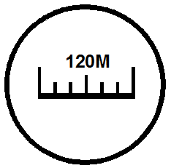  

**Full HD 1080P@60Hz Support TCP/IP 120m long distance Built-in ESD protection**

 

**Local output**

**Point to Multi-point IR passback Plug and play**

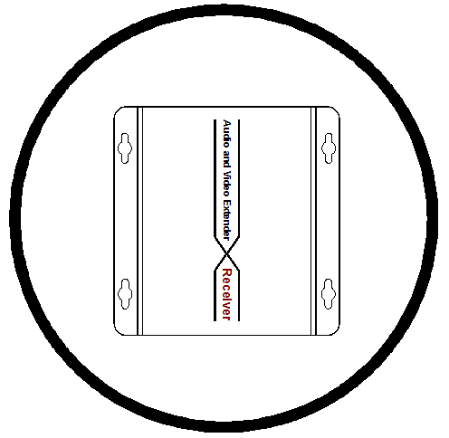

**Slim aluminum shell**

**4. Specification**

|  |  |  |
| --- | --- | --- |
| **Parameter** | | **Description** |
| Video | Standards | HDMI 1.3; HDCP 1.2 |
| Maximum pixel clock | 165MHz |
| Maximum data rate | 6.75Gbps |
| Resolution | Max: 1920X1080@60Hz |
| Connector | HDMI-A |
| Impedance | 100Ω |
| IR | Interface | 3.5mm earphone seat |
| Signal direction | Unidirectional |
| Signal type | Digital |
| IR frequency | 38kHz |
| Ethernet | Interface | RJ45（568B） |
| Transmission distance | UTP CAT5e---120m |
| Other | Power supply | The power adapter: DC 5V |
| Power dissipation | MAX 4W |
| Temperature | Operating: -5℃ ~ +70℃ |
| Humidity | Operating: 5% ~ 90% |
| Dimension | 100*97.5*18.6mm |
| The warranty | 1 year free warranty |

1. **5. Panel**

Sender：

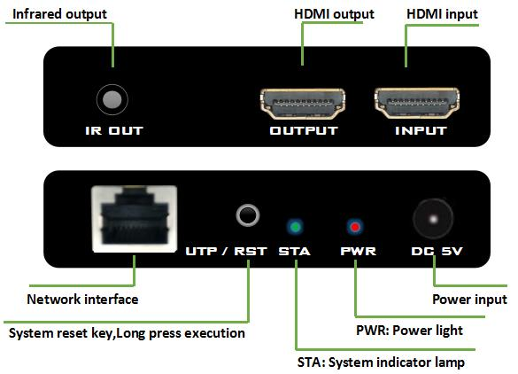

Receiver :

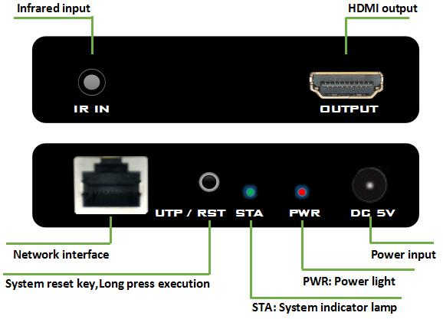

**6. Installation Steps**

1. Connect the provided DC/5V power supplies to the power socket of the transmitter and the receiver,
2. Connect an HDMI cable between the HDMI input port of transmitter and the HDMI output port of the video source,
3. Connect the HDMI output port of receiver to the display device with HDMI cable,
4. Connect the transmitter RJ45 port to the receiver RJ45 port using a single CAT6 cable.
5. IR function---connect the IR TX (the bigger) cable to the HDMI receiver, connect IR RX cable to the HDMI transmitter and the IR TX must face to the controlled device.

**7. Packing List**

* HDMI extender transmitter x 1
* HDMI extender receiver x 1
* IR sender and receiver cable x 1
* Power adapter x 2
* Instruction manual x 1

**8. Using Diagram & Application**

**One to one**

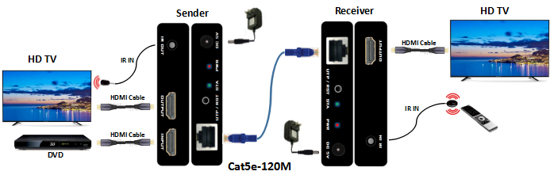

**One to many**

