# 60M HDMI Extender With Loopot & Dual IR

User Manual

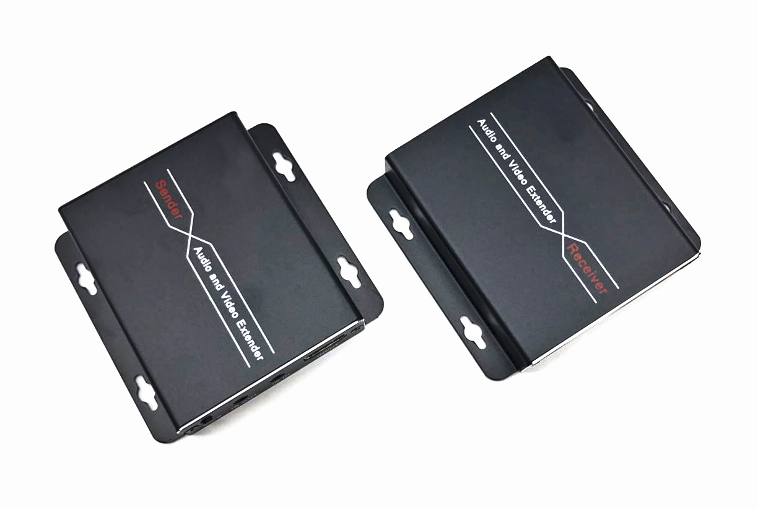

1. **PRODUCT DESCRIPTION**

This HDMI Extender includes a transmitter unit (TX) and a receiver unit(RX), working as a pair. It allows for transmission and extension uncompressed full HD 1080p@60Hz HDMI signal via CAT6/6A/7 network cable, the transmission distance is up to 60 meters with zero latency. At the same time, the signal is stable, and the built-in EDID greatly improves the compatibility of the device. It supports two way IR remote control and local loopout , also it supports PoC to power the sender/receiver (Connect power supply to the transmitter /receiver, each unit will power up, as the unit through network cable). This product is perfect for AV transmission in applications of HD conference system, HD video shooting, HD multimedia education system, HD digital advertising and signage etc.

The device has a long transmission distance, low use cost, convenient installation and good compatibility, and it is a stable and efficient transmission method.

1. **ADVANTAGE**

* Aluminum alloy housing design, stable and durable ;compact size and Slim ,strong anti-interference, Wall-mounted type is more convenient;
* Uncompressed transmits HDMI video and audio signals up to 60M over a single CAT6 cable;
* Support video resolution up to 1920*1080@60Hz, 3D signal;
* Support 2-way wide band infrared signal transmission;
* Support local loopout in sender
* Build-in EDID function, can match many kind display device;
* Support POC unilateral power supply, need 1pc 12V power to TX/RX
* Compliance with HDMI 1.3 and HDCP 1.2 standard;
* Ethernet cables with a standard IEEE - 568b connection, convenient installation;
* High compatibility, can auto-match source and display device;
* Built-in automatic adjustment system, make the image smooth, clear and stable;

1. **FEATURES**

  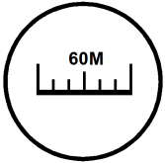 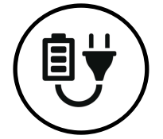

**Uncompressed 1080P@60Hz Support 3D 60M Distance POC function with 1 power**

 ** **

**Local loopout IR control Smoothing & Real time Plug and Play**

** ** 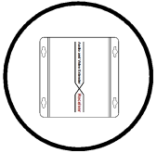

**Ultra-thin aluminum shell**

**Strong compatibility & automatic recognition**

**Built-in ESD protection**

**HDCP 1.2; HDMI1.3**

**4.PACKING LIST**

* HDMI extender transmitter x 1
* HDMI extender receiver x 1
* IR sender and receiver cables x 1
* Power adapter x 1
* Instruction manual x 1

**4.SPECIFICATION**

|  |  |  |
| --- | --- | --- |
| **Parameter** | | **Description** |
| **Video** | Standards | HDMI 1.3; HDCP 1.2 |
| Maximum pixel clock | 165MHz |
| Maximum data rate | 6.75Gbps |
| Maximum resolution | 1920*1080@60Hz （backward-compatible） |
| Connector | HDMI-A |
| Impedance | 100Ω |
| **IR** | Interface | 3.5mm earphone seat |
| Signal direction | Bi-directional |
| Signal type | Digital |
| IR frequency | 20-60kHz |
| **UTP** | Interface | RJ45 (IEEE - 568b connection) |
| Transmission distance | CAT6-60M |
| **Other** | Power supply | The power adapter: DC 12V |
| Power dissipation | MAX 3W |
| Temperature | Operating: -5℃ ~ +70℃ |
| Humidity | Operating: 5% ~ 90% |
| Dimension | 82*65*17mm |
| The warranty | 1 year free warranty |

**5.INTERFACE**

**Sender**

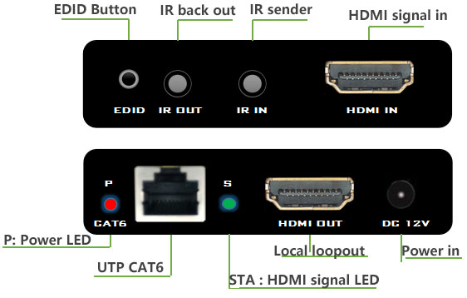

**Receiver**

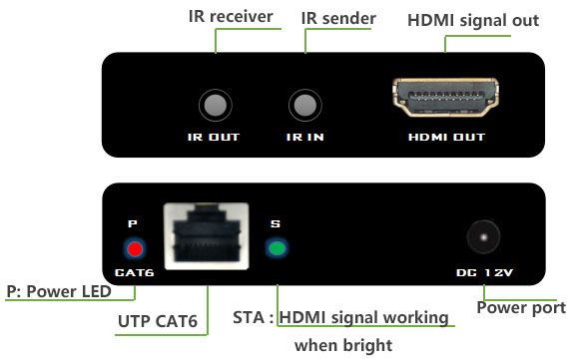

**6.INSTALLATION**

1. The HDMI signal source (such as set-top boxes, Blu ray DVD, computers, etc.) access to the HDMI Sender;
2. Connect the local Monitor to the HDMI sender’s HDMI output.
3. Connect the HDMI Receiver to the display device (such as a high definition TV, a tiled screen, etc.);
4. Use the network cable (recommended 6 types of cable) to connect the sender and receiver network interface;
5. Will be the transmitter or the receiver connected to a power source, when the lamp lights up normally, normal operation of system.
6. EDID key uses, such as after connecting a POWER, indicating STA long bright, the receiving end of the POWER, indicating STA long bright, display no image or color, the transmitter electricity HDMI and transmitter monitor HDMI port connection, press the EDID button until the STA lights flashing, flashing stop after the restart repeat steps 1-4 to power.

**7.CONNECTION DIAGRAM**

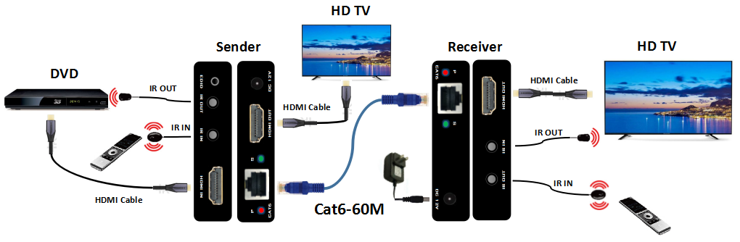

1. **FAQ**

**1, No image and no video show in TV monitor ?**

A :The HDMI should is max 1080P, and the Monitor set up 1080P resolution out .

Check the STA and PWR LED lighting ;

Check your cables is UTP Cat6;

Check the Network cable head is **568B** series ;

Don’t roll the UTP Cat6 ,stretch out .

**2, Could use Cat5e ?**

A: Sure . Use the UTP Cat5e distance up to 30meters .

**3, Why the product was burned ?**

A: Should use the correct network cable head ,it is 568B , because the receiver is PoC function, if the the Ethernet cable series is not 568B, will causing a short circuit.

**4.About the Ethernet cable( cat5e, cat6, cat7)**

First it’s must UTP ; The cable is cat5e, then the Crystal head is for cat5e; the cable is cat6 ,then the head should for cat6.