# 4K@60HZ HDMI Extender 60M

# With Loopout & Dual IR

User Manual

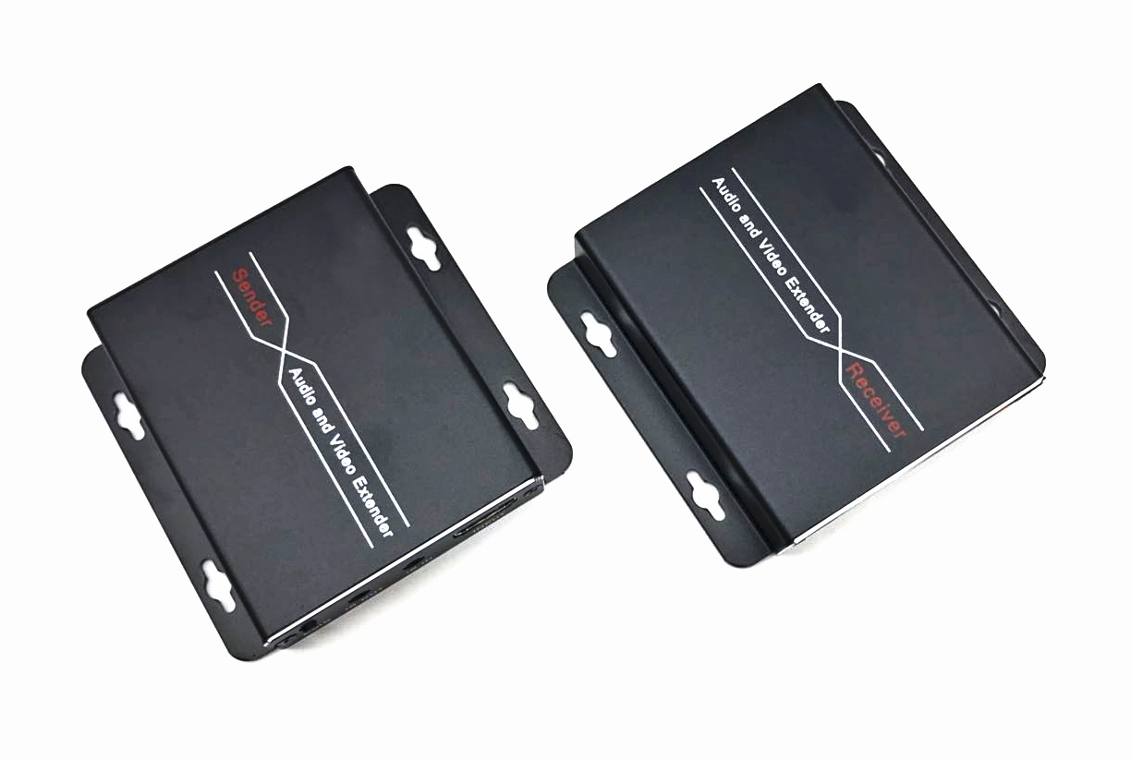

1. **PRODUCT DESCRIPTION**

This HDMI Extender includes a transmitter unit (TX) and a receiver unit(RX), working as a pair. It allows for transmission and extension uncompressed full HD 4K@60Hz HDMI signal via CAT6/6A/7 network cable, the transmission distance is up to 60 meters with zero latency. At the same time, the signal is stable, and the built-in EDID greatly improves the compatibility of the device. It supports two way IR remote control and local loopout . This product is perfect for AV transmission in applications of HD conference system, HD video shooting, HD multimedia education system, HD digital advertising and signage etc.

The device has a long transmission distance, low use cost, convenient installation and good compatibility, and it is a stable and efficient transmission method.

1. **ADVANTAGE**

* Aluminum alloy housing design, stable and durable ;compact size and Slim ,strong anti-interference, Wall-mounted type is more convenient;
* Uncompressed transmits HDMI video and audio signals up to 60M over a single CAT6a/7 cable;
* Support video resolution up to 3840*2160@60Hz, 3D signal;
* Support bi-direction wide band infrared signal transmission;
* Support local loopout in sender
* HDMI 2.0 and HDCP 2.2 standard;
* Build-in EDID function, can match many kind display device;
* Ethernet cables with a standard IEEE - 568b connection, convenient installation;
* Built-in ESD protection
* High compatibility, can auto-match source and display device;
* Built-in automatic adjustment system, make the image smooth, clear and stable;

1. **FEATURES**

  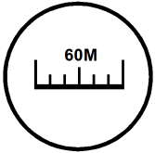

**4K@60Hz Support 3D 60M Distance Local loopout**

 ** **

**Bi-direction IR Smoothing & Real time Plug and Play HDCP 2.2; HDMI2.0**

**4.PACKING LIST**

* HDMI extender transmitter x 1
* HDMI extender receiver x 1
* IR sender and receiver cables x 1
* Power adapter x 2
* Instruction manual x 1

**4.SPECIFICATION**

|  |  |  |
| --- | --- | --- |
| **Parameter** | | **Description** |
| **Video** | Standards | HDMI2.0; HDCP 2.2 |
| Maximum pixel clock | 340MHz |
| Maximum data rate | 18Gbps |
| Maximum resolution | 3840*2160@60Hz （backward-compatible） |
| Connector | HDMI-A |
| Impedance | 100Ω |
| **IR** | Interface | 3.5mm earphone seat |
| Signal direction | Bi-directional |
| Signal type | Digital |
| IR frequency | 20-60kHz |
| **UTP** | Interface | RJ45 (IEEE - 568b connection) |
| Transmission distance | CAT6-60M |
| **Other** | Power supply | The power adapter: DC 5V/1A |
| Power dissipation | MAX 3W |
| Temperature | Operating: -5℃ ~ +70℃ |
| Humidity | Operating: 5% ~ 90% |
| Dimension | 82*65*17mm |
| The warranty | 1 year free warranty |

**5.INTERFACE**

**Sender**

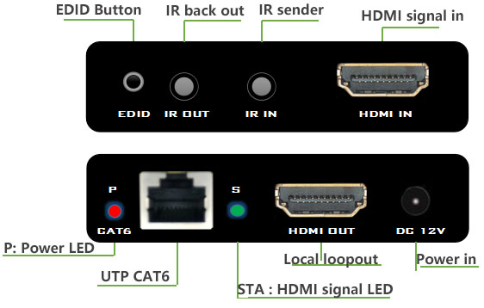

**Receiver**

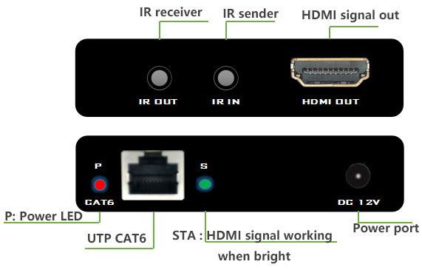

**6.INSTALLATION**

1. The HDMI signal source (such as set-top boxes, Blu ray DVD, computers, etc.) access to the HDMI Sender;
2. Connect the local Monitor to the HDMI sender’s HDMI output.
3. Connect the HDMI Receiver to the display device (such as a high definition TV, a tiled screen, etc.);
4. Use the network cable (recommended 6 types of cable) to connect the sender and receiver network interface;
5. Transmitter and the receiver connected to powers, when the lamp lights up normally, normal operation of system.

**7.CONNECTION DIAGRAM**

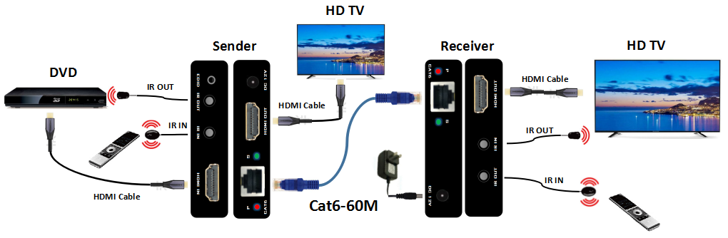

1. **FAQ**

**1, No image and no video show in TV monitor ?**

A :Check the STA and PWR LED lighting ;

Check your cables is UTP Cat6;

Check the Network cable head is **568B** series ;

Don’t roll the UTP Cat6 ,stretch out .

Press the EDID : only use the Sender connect Monitor by HDMI cable and press EDID

**2, Could use Cat5e ?**

A: No . the 4K video data is 18Gbp with uncompressed that too large ,must use cat6/7.

**3, Why the product was burned ?**

A: Should use the correct network cable head ,it is 568B , because the receiver is PoC function, if the the Ethernet cable series is not 568B, will causing a short circuit.

**4.About the Ethernet cable( cat5e, cat6, cat7)**

First it’s must UTP ; The cable is cat5e, then the Crystal head is for cat5e; the cable is cat6 ,then the head should for cat6.